<!--This file created 2:29 PM 10/29/97 by Claris Home Page version 2.0-->3.5 Project
When Is Your Coffee Cup Stablest?

Your car has no cup-holder, so you must sit your filled coffee cup on the passenger seat beside you when you start out in the morning. Bitter experience has taught you that the cup is least stable — and most prone to spill — when it's completely full, but gets more stable as you drink the coffee and thereby lower its level in the cup. Now you're ready to apply calculus to analyze this phenomenon!

Figure 3.5.22 in the textbook shows a coffee cup partially filled with water. It is stablest when the centroid of the cup-plus-coffee is lowest. The centroid of a solid cylinder or cylindrical shell is its geometric center-point, and the y-coordinate of the centroid of a composite body consisting of several pieces with masses 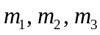 having centroid y-coordinates 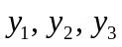 (respectively) is given by

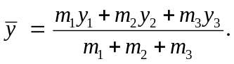 (1)

This formula says that is an average of the individual centroid y-coordinates 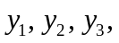 with each of them weighted by the corresponding mass.

The somewhat stylized coffee cup in Fig. 3.5.22 consists of

- A side surface that is a cylindrical shell with height H, inner radius R, and thickness T, and
- A bottom that is a solid cylinder with radius 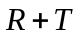 and height B.

First show that the bottom of the cup has centroid y-coordinate and mass

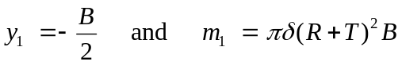 (2)

where denotes the density of the material used to make the cup. Then explain why the curved cylindrical shell side of the cup has centroid y-coordinate and mass

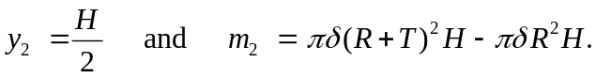 (3)

Finally, if the cup is partially filled with coffee with depth y and density 1 g/cm³, then the centroid y-coordinate and mass of the coffee itself are given by

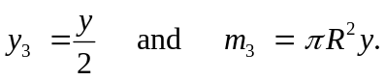 (4)

Substitution of these centroid y-coordinates and masses in (1) and simplification yield the function

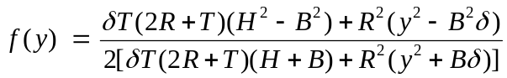 (5)

giving the centroid y-coordinate 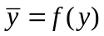 of the cup-plus-coffee as a function of the depth y of the coffee in the cup. For instance, if we take 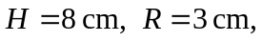
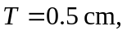 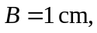 and 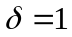g/cm³, then (5) simplifies to

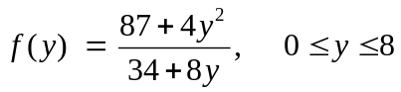 (6)

Figure 3.5.23 in the textbook shows the graph of the function f. It appears that the centroid is lowest when 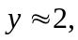 and thus when the cup is about one-quarter filled with coffee. To find when 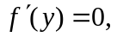 you can differentiate (2) and simplify to obtain

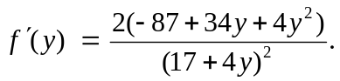 (7)

Obviously this derivative vanishes only when its numerator vanishes. Therefore you need only solve a quadratic equation to see where the numerator is 0: When
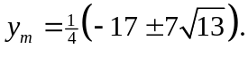 The positive solution gives the optimal depth 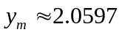 cm of the coffee in your cup — just a bit more than a quarter of the cup's height of H = 8 cm.

Remark: You might substitute this numerical value of y_{m} back into (6) to show that 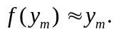 Indeed, with persistence you can substitute the exact value of y_{m} and simplify radicals to show that the cup-with-coffee is stablest when its centroid lies precisely at the coffee surface.

Carry out this analysis with your own favorite coffee cup. Measure it's physical dimensions 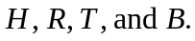 How can you determine the approximate density of its material?

For a more realistically shaped coffee cup, the algebra gets a good deal more complicated. For an interesting discussion of further possibilities, see Andrew Simoson, Fast-Food-Frusta and the Center of Gravity, The College Mathematics Journal, volume 31 (September 2000), pages 303-306.

